**Docker Hands-on:**

Docker file for springboot application:

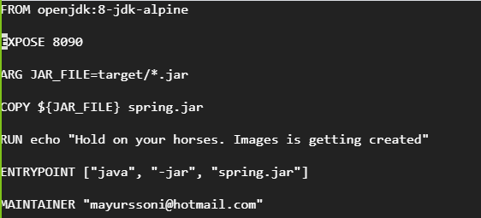

Docker build command and output

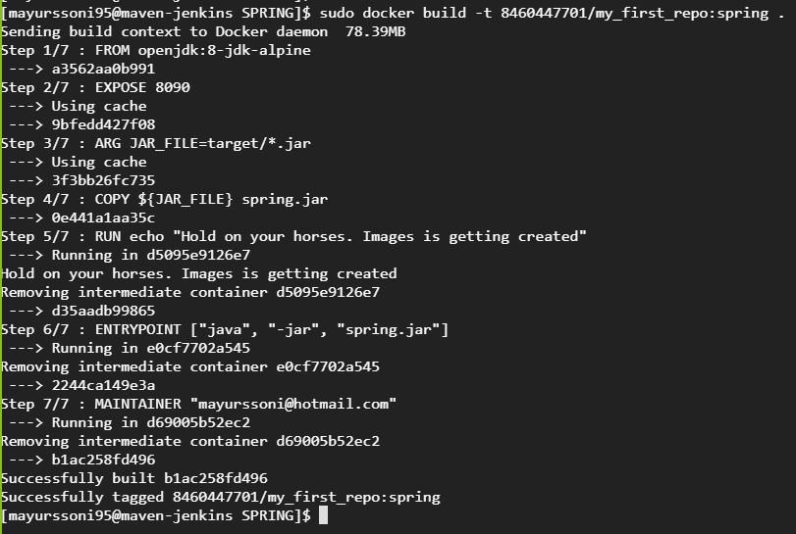

Docker Login:

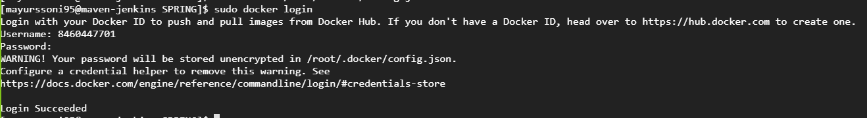

Docker Push:

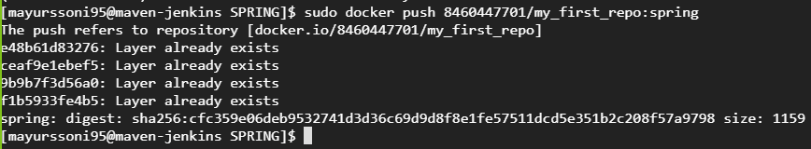

Docker Run:

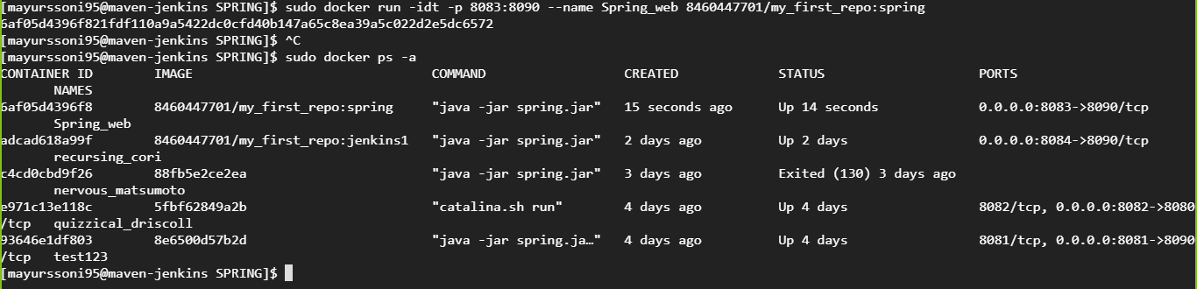

Website up after running docker run command.

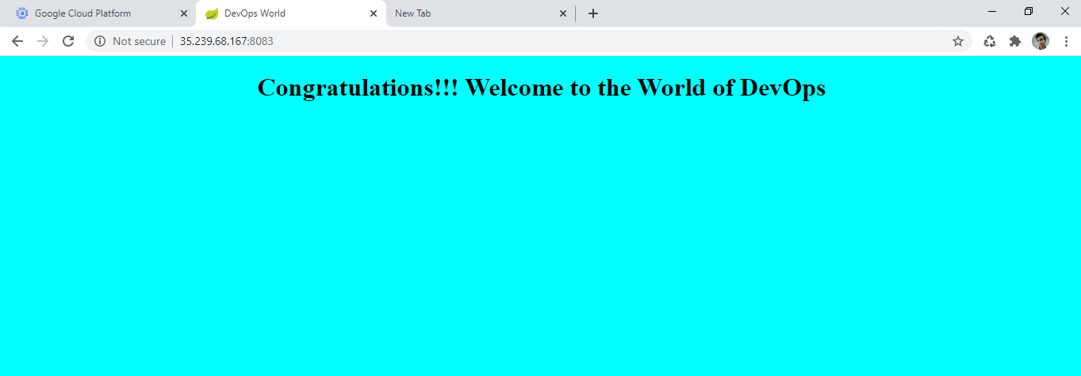

Docker file for webapp using war:

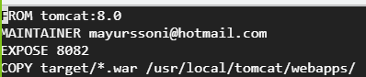

**Docker-compose:**

Docker-compose file  
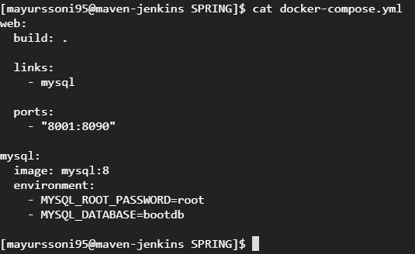

Docker-compose run:

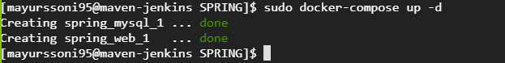

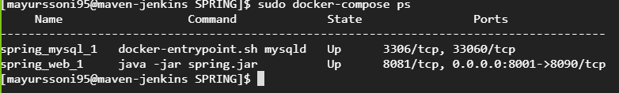

Verification of mysql container:

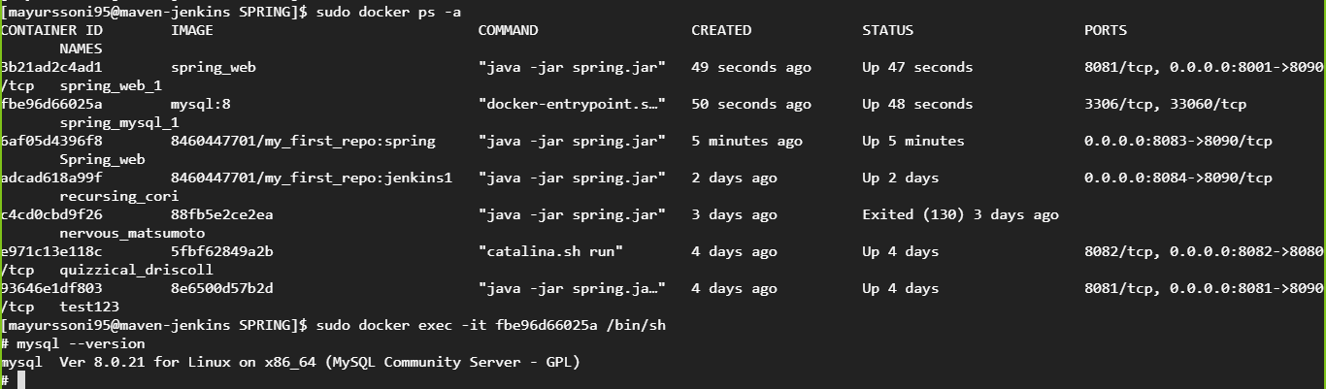

Verification of spring-boot application running on 8001:

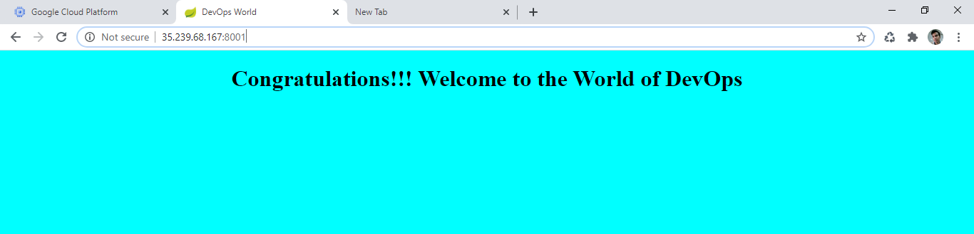

Stop compose containers:

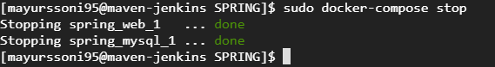

Remove stopped containers using compose:

